Workings of the ASAPGrid in HANtune

Version 1.0

by Bastiaan Stueck.

Copyright (c) 2020 [HAN University of Applied Sciences]

Permission is hereby granted, free of charge, to any person obtaining a copy of this software and associated documentation files (the "Software"), to deal in the Software without restriction, including without limitation the rights to use, copy, modify, merge, publish, distribute, sublicense, and/or sell copies of the Software, and to permit persons to whom the Software is furnished to do so, subject to the following conditions:

The above copyright notice and this permission notice shall be included in all copies or substantial portions of the Software.

THE SOFTWARE IS PROVIDED "AS IS", WITHOUT WARRANTY OF ANY KIND, EXPRESS OR IMPLIED, INCLUDING BUT NOT LIMITED TO THE WARRANTIES OF MERCHANTABILITY, FITNESS FOR A PARTICULAR PURPOSE AND NONINFRINGEMENT. IN NO EVENT SHALL THE AUTHORS OR COPYRIGHT HOLDERS BE LIABLE FOR ANY CLAIM, DAMAGES OR OTHER LIABILITY, WHETHER IN AN ACTION OF CONTRACT, TORT OR OTHERWISE, ARISING FROM, OUT OF OR IN CONNECTION WITH THE SOFTWARE OR THE USE OR OTHER DEALINGS IN THE SOFTWARE.
Table of Contents
1. Introduction 3
2. The GUI 4
3. The internal workings 5

1. Introduction
This document will give a brief overview of the new visual ASAPGrid UI component I implemented in HANtune. The purpose of this is giving a quick start to both users and future programmers working with the HANtune project.

For normal users, I wrote section two. This section should be understandable for people with basic knowledge in ECU's, DAQlists, etc. Section two can be taken out and inserted into a general manual, if required.

Section three was made for future HANtune programmers. It describes how the ASAPgrid is structured, and how it can be expanded.

2. The GUI
The DAQgrid allows you to view all elements in the currently loaded ASAP2-file. It also allows toggling these elements on and off for each active DAQlist.
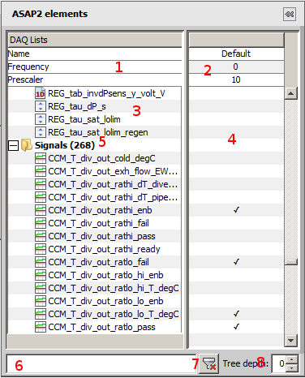

An overview of the DAQgrid

1 The header, this is where some persistent data and settings are listed for you to edit and/or view, on a per DAQlist basis. You can, for example, quickly set the prescaler here.

2 The actual settings in the header, you can edit most of those.

3 The elements. Doubleclick on these to place a default editor or viewer into the current layout. Rightclick for a popupmenu. Categories (see 5) can be folded.

4 In this area you can toggle the element on or off for each active DAQlist.

5 A category, these can be collapsed and expanded.

6 The current filter, type something here to filter the shown elements.

7 Clear the current filter, showing all elements.

8 Maximum depth to show, 0 shows everything.

3. The internal workings
At the core of the ASAPGrid is the is the ASAPGrid class, this class extends JPanel to act as a visual swing component, while internally using 4 JTable-descendants to display the data.

Each DAQ element receives a backing TreeGridNode object, that contains the data needed for displaying said element in the tree structure of the ASAPGrid. Likewise, each setting displayed in the header is backed by a SettingDisplayItem instance.

The display of elements and settings, and their edit functionality is mostly implemented with custom TableCellRenderers and TableCellEditors.

The code is of course heavily documented with both inline comments and Javadoc.

